River of Dreams
A Spiritual Memoir
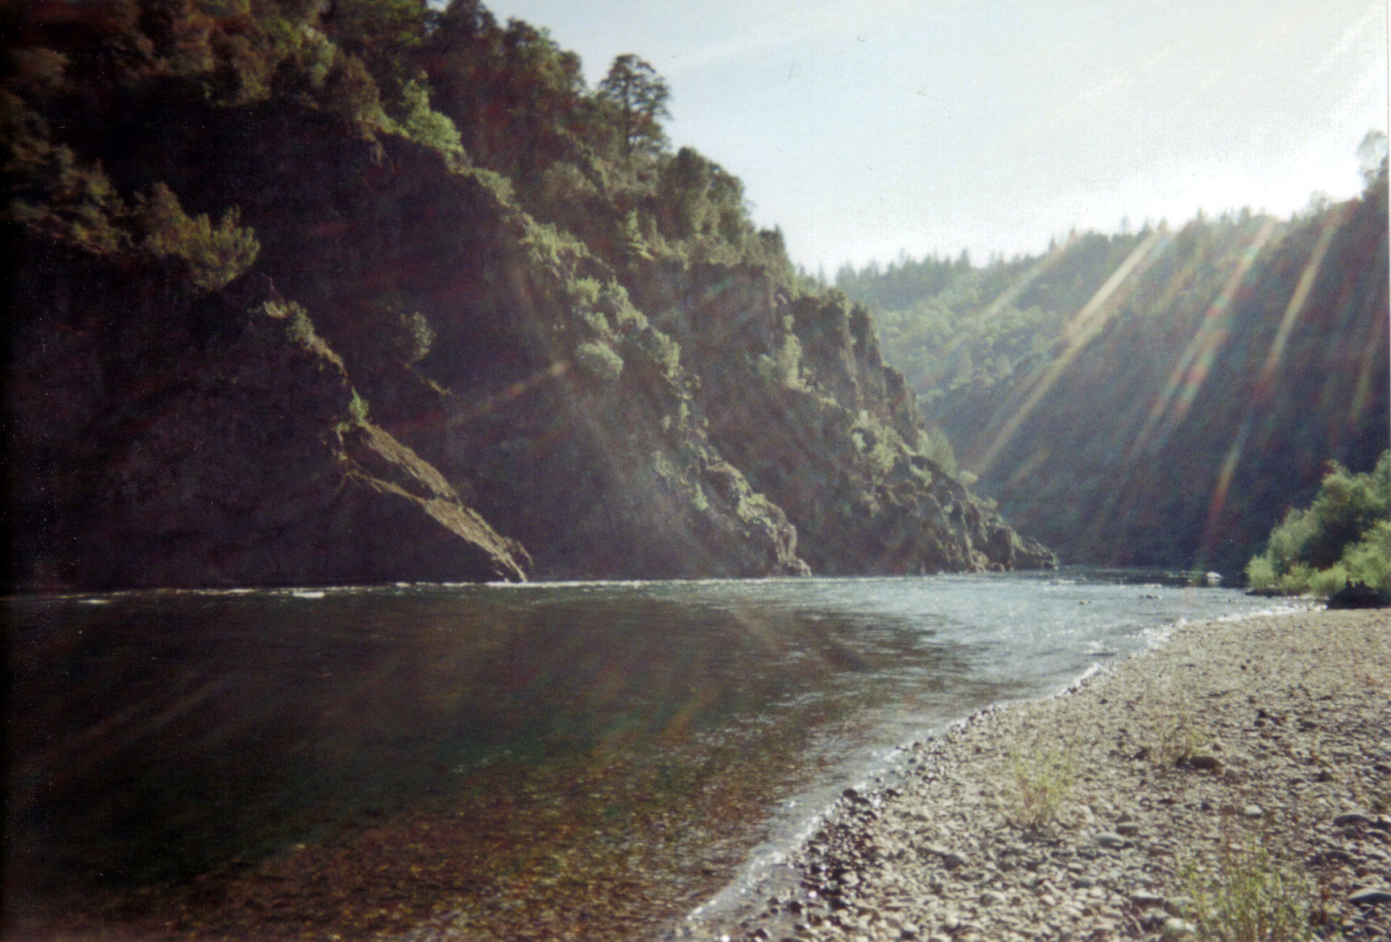
Adam Sunshine
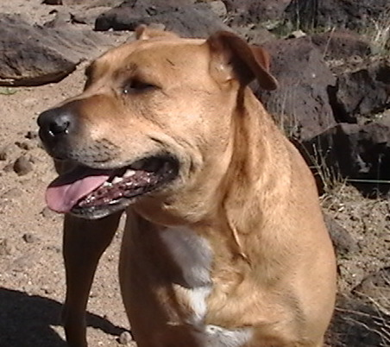
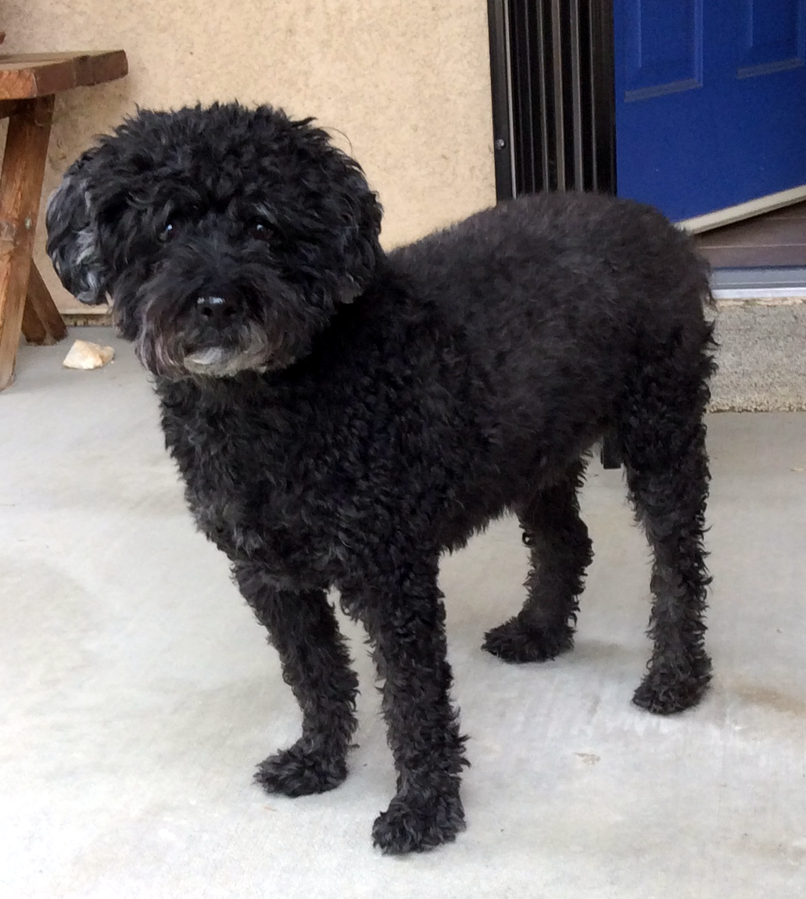

Dedicated to Toby Dog (2002–2012) & Lance, my service dog (2009–2019), both of whom provided far more comfort and love than I could have ever imagined. Thank you, dear buddies.
And to the children of the Future, that they and the wild creatures may live in a safe, clean world, free from the ravages of war and needless suffering.

ACKNOWLEDGMENTS
I would like to thank my dear friend, writer, actor, dancer, and editor Susie Hara, for her exceptional work. I first met Susie in 1983, when she joined me and a dozen other talented dancers to perform a choreographed and improvisational “Dance for Nuclear Disarmament” outdoors, with live music, at the Embarcadero Plaza in San Francisco. While there has been progress in the reduction of nuclear weapons there is much work still to be done. Significantly, the Treaty on the Prohibition of Nuclear Weapons opened for signature at United Nations headquarters in New York on September 20, 2017. On October 24, 2020, the treaty reached its 50th ratification, meaning that on January 22, 2021, it has entered into force. It is OK now to simultaneously disarm all weapons of mass destruction. Observations and recordings and documentations of these kind acts are a path to International Peace.

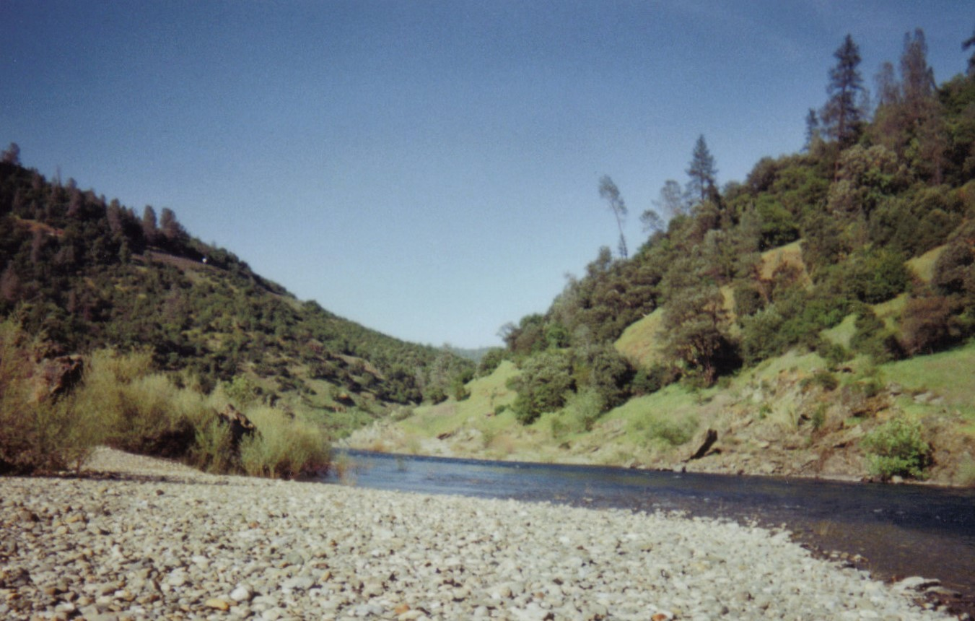
North Fork of the American River, Auburn, California
Introduction
I first began keeping a dream journal when I took a course at the University of California, Santa Cruz, called “Birth of a Poet.” Taught by the poet William (Bill) Everson, it was known as an easy class, but if you had an artistic drive he was a brilliant teacher and storyteller who triggered many inner motivations to unlock creativity. The only requirement was to keep a dream journal that we would sometimes share orally in class in what he called the Dream Circle. Drawing inspiration from Native Americans who would share their dreams in small communities, each person was thought to hold part of a dream puzzle that, once shared by everyone, would complete the puzzle, and assist the tribe in their challenges to survive in a sacred but often dangerous world.
This was my first year of college and I was tired of school by then and itching to get into the “real” world and experience life outside of school. So I took a year off, first living in a spiritual community that studied the teaching of Gurdjieff, Ouspensky, and J.G. Bennett. We did an adaptation of Sufi dancing called the Movements, which ultimately drew me into the world of dance. My intuition told me that I was a “dancer of the soul” and what was unthought of previously became a passion of great delight.
Then I decided that I needed to travel outside of the U.S. and went to Greece to study the sacred art of the Greek Orthodox Church on the Mt. Athos peninsula in northern Greece. I had to get a special visa to visit the area, as they wish to keep visitors to a minimum so as to not overwhelm the monks who follow a sacred tradition. A fascinating place without any women, electricity, or modern conveniences, it was like stepping into the Middle Ages. I would hike from monastery to monastery where they welcomed me with retsina, a traditional Greek wine, or Ouzo, a strong liquor that really had a kick if you drank too much. The icons were astounding, unlike anything I had ever seen. One monastery was perched on a steep hillside overlooking the Aegean Sea. The primitive toilets were just holes cut out of the wood and you could see the ocean waves hundreds of feet below. At a Russian monastery, one monk took me on a tour that he said they rarely showed visitors. First there was a room of icons painted with gold. Then he unlocked a room where the skulls of monks were kept on shelves dating back hundreds of years. The monk explained that this tradition was both to honor the monks and to remind the living monks that life here was temporary, so it was a good idea to focus on your religious life in preparation for the life to come after death.
From there I went down to Athens to learn more about Greek art history. I had a great time as the Greek people were so friendly, often welcoming me into their homes as a special guest. I travelled down to Crete and Santorini to explore Minoan art. When I arrived in Santorini there were scientists from all over the world who had come to see a rare total eclipse of the sun. An unexpected surprise!
Next I spontaneously decided to go to Israel where the winter was milder and I was able to live and work on a kibbutz, an Israeli commune. I did a lot of hard work, picking citrus fruit or helping the kitchen crews feed the 100+ people living on the kibbutz. It gave me a home from which I could travel around the country, visiting Galilee and Jerusalem, one of the most beautiful cities in the world.
Topping off my travels with a short stay outside London, I eventually grew homesick and was now motivated to return to California and finish up my college degree at New College of California, founded by a Jesuit brother. It offered small group seminars and independent learning. My last year included an in-depth study of the cooperatives of Santa Cruz County, ranging from food co-ops, financial co-ops (or credit unions as we know them), housing co-ops, and even agricultural co-ops, where farmworkers were able to prosper by being co-owners of their business instead of low-paid, migrant workers. It was very fulfilling.

CHAPTER 1
A Taste of Life After Death
1976
My life flashed before my eyes as my body collapsed onto the floor of my doctor’s office in San Francisco. In a nanosecond my brain was flooded with an immense amount of information before the smell of ammonia that a nurse waved under my nose woke me from what was a simple fainting episode, common after a blood draw. In that brief period watching my life flash by, I understood that all my worries and anxieties about my imperfections, mistakes, and insecurities were unnecessary. I was led to believe that the only judge then and after I die is myself. There is no judge or jury to face after I die, judgment is simply a behavior of our Earthly world, necessary for our safety but often an issue that prevents us from achieving inner peace. So without judgment, we are free to exist in a destination where love is the prevailing force embracing all that is. Trusting in this truth freed me from burdens that were preventing me from fully being myself. Although I was still a 20-year-old young man without a clue as to what I was supposed to do with my life, I no longer needed to worry that I might do something wrong. It was such a relief. I could just be an ordinary person and that alone was entirely satisfactory.
My twenties passed quickly and with purposeful meaning. In 1983, after working as a manager for a few credit unions, I joined a friend who was a venture capitalist in the tech start-up world. At the same time, I pursued a career in modern dance, performing frequently in San Francisco and in collaboration with pioneering computer graphic video artists in live performances at the Edinburgh Fringe Festival or in television productions on PBS and the BBC.
I found balance in meditation and the spiritual exercise of Subud, or Susila Budhi Dharma, during this period. This discipline helped offset the oppressive materialism that dominates so much of American culture. At the age of thirty, I decided to relocate to Seattle, where I began a decade of public service in non-profits. During this time I began to experience more profound dreams and visions. The intersection of my inner and outer life began to unfold in ways I never imagined. That is where we begin the story of what I call “The River of Dreams.”
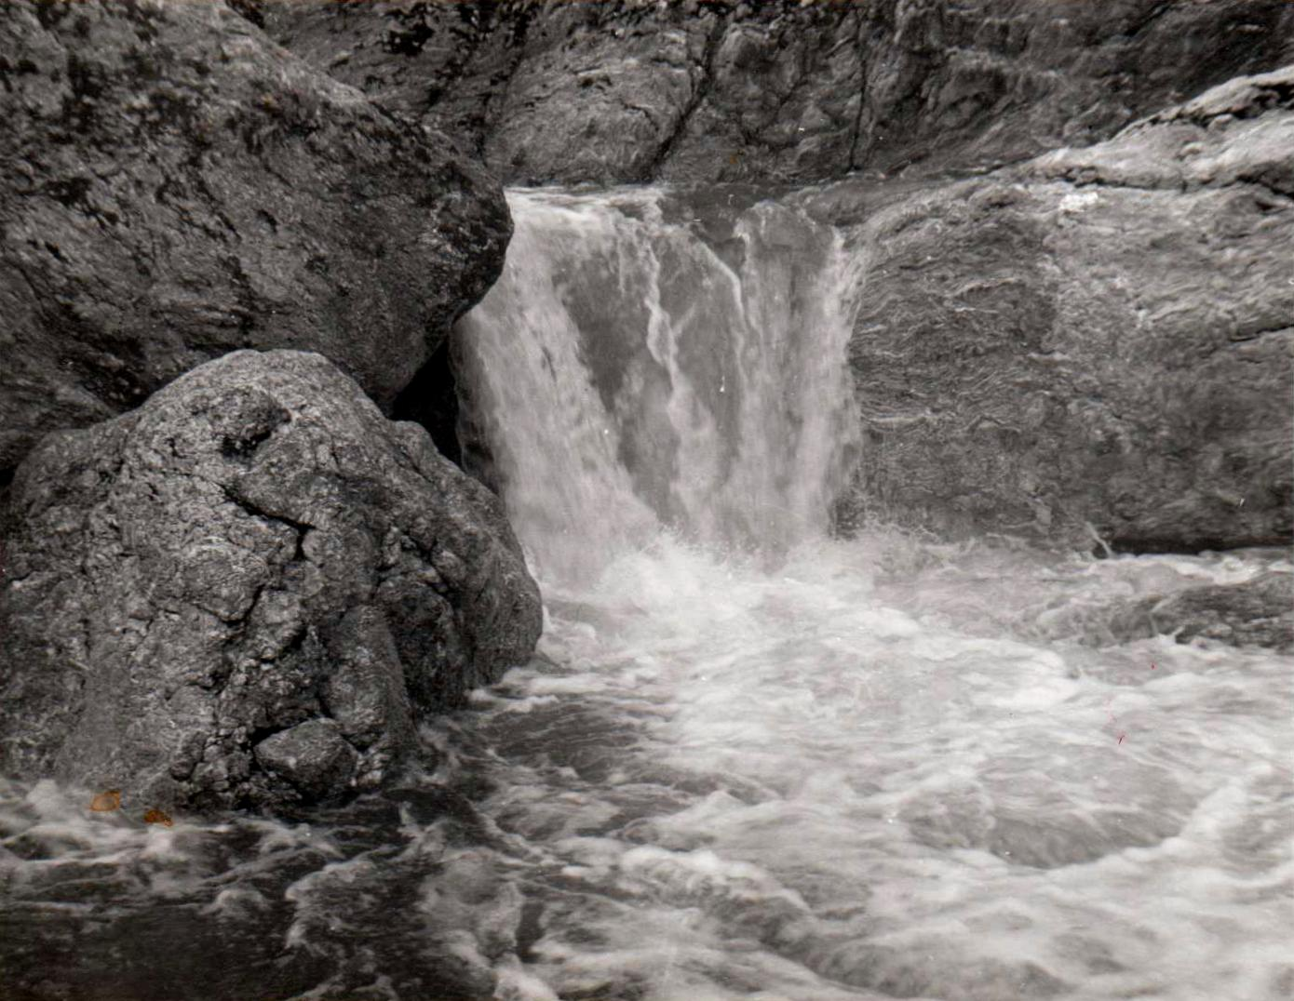
Waterfall at Sunol Regional Park, Sunol, California

CHAPTER 2

The Force of Manu
1989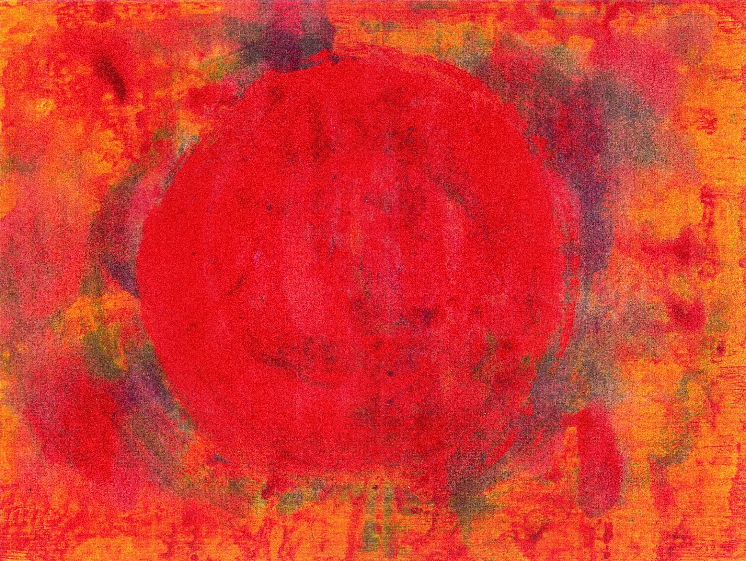

“Solstice” painting by Adam Sunshine

In the late 1980s I was working as the Director of Subud USA, a small spiritual organization. One afternoon I felt a headache coming on. It started to feel like a migraine, so I left work about an hour early. It hung on overnight but the next day I went to work anyway. I left early again as it got worse in the afternoon. I went to bed with my head still throbbing. Around 4 AM I had the following intense, lucid dream, which broke the headache.
Driving north through California, in an invisible car, I see Mt. Shasta on the left. It is stunning, rugged and snow covered. The mountain is almost a pyramid in shape with sunset-colored clouds throughout the sky. As I move past the mountain I notice that there is no snow on the north slope, which seems a bit strange.
Next, I am walking up a hill where I meet a man and a woman. Their style of dress and hair and their manner of speaking are like people from the 1950s. They comment that this is the view of Los Angeles that all the postcards have. I turn around and see Mt. Shasta in back of two huge, stepped pyramids. In front of the pyramids is a road lined by giant palm trees.
The three of us begin to walk up the hill again, but it has changed into another stepped pyramid. Near the top we walk into a chamber where a fourth man joins us. He is also in 1950s attire. The woman points out the sun calendar and then points to a symbol called “HALOS” which she says is going to happen any moment. I look at the symbols and say, “she’s right, it is due any second.”
The woman finds some things and says we must put them on if we are to be protected. They are a pair of sunglasses, a scarf/bandana, and a hoop with a bell on it that we place around our ears. Then we are supposed to lie down on the moist earth, not in the shade, but in the direct light of the sun. I ask her if she’s sure this will work, “we look more like some people from the Mission (district of San Francisco) than that we are protected from anything.” She says she’s sure and we lay down on the ground just as the sun begins to brighten in intensity 2–3 times its normal light. This lasts for several seconds and then recedes. But we all understand that the electromagnetic and chemical structure of all things on Earth has been permanently changed.
We look out at Los Angeles below us and hear cries of panic and an explosion or two from gas lines near the freeway. We walk back into the pyramid, somewhat stunned but also full of understanding that, of course, that was how it was supposed to happen. Inside the pyramid we realize we are all changed and possessed by the spirit of CHIEF MANU, whose force ruled the pyramid, and for whom the pyramid had been built. This power actually takes over my body and forces me to pick up a gun and shoot one of the men. The other man yells at me to throw him the gun, and because I feel guilty for shooting the man, even though I had no power to control the act, I throw him the gun. The man then says he is going to shoot me but when he picks up the gun his own arm is possessed by the force which makes him shoot himself.
The woman and I are left looking at each other, somewhat surprised, but also knowing that all of this was meant to be, it was planned long ago. We could feel the presence of CHIEF MANU and understand that this was a change that would affect the world entirely.
The scene then changed to Greece and the Mediterranean Sea, where Chief Manu was to teach me some lesson. But then my alarm went off and I awoke, remembering the intensity of the light of the sun.
When I got to work I decided to write the dream down since it was still a vivid memory. I had never remembered a dream like this one. These were the days before the internet, but some of our computer engineer members had devised a messaging system through MCI mail that functioned like an internet chat group does today. We were able to communicate with our Board of Directors and membership in the United States in an inexpensive way through this system.
Once I finished writing the dream I sent it out to an informal group on the chat group “Starcomm” to see if anyone knew anything about this force of Manu that had penetrated my dream. There was no such thing as Google or the search function back then. Unfortunately, no one knew much about Manu but they were all intrigued by the dream and thought it was important somehow. A few days later I went to the Theosophy library that was near my home in Seattle. I looked up Manu and learned that in the Hindu and Vedic tradition there was always a Manu that presided over the Earth for long periods of time. Manu was sometimes considered the first man, like Adam. He also was a bit like Noah and the story goes that a fish, to whom Manu had done a kindness, warned him of an upcoming flood. Manu built a boat and saved life from extinction. Manu was also sometimes thought of as the “Hand of God.” And the first known written laws were written by Manu and are known as the Manu smriti. However none of this information really helped me figure out what the dream might mean other than the powerful force might be the “Hand of God” in some fashion.
So I forgot about the dream until a few months later when an unusual letter arrived at work. It was a short letter inviting me to Malaysia because they had heard of my dream and were holding a conference on the topic of “Doomsday, Are We Facing the End Times?” I did not recognize the name of the writer or the group they represented, which was GPDC, the Golden Path Development Center.
After a week or so I decided to call them. It turned out GPDC was part of the Subud group in Kuala Lumpur. They had spun off their own group but also did the spiritual meditation of Subud too. A Subud member had forwarded them my dream, which contained some similar information that they had received in their meditations. Now I understood. However, after a few years of working in non-profits and spending my other time in a modern dance company, doing performance art, working on an independent film and painting, I did not have any extra money to travel. No problem, they said, they would forward me a plane ticket and arrange a place to stay with one of their leaders.
On the way to Kuala Lumpur I had an overnight stay at a hotel near the Tokyo airport. About 3:30 in the morning I was jolted awake and nearly thrown out of bed by an earthquake. It was one of the strongest I have ever felt, and I grew up in California along an earthquake fault. There was still electricity so I turned on the television to see if there was any news about the quake. Nothing. I put on some clothes and went downstairs to see if there was any information or panic from the other guests. Again, nothing, everything was normal. Finally I found an employee who spoke English and he just said, “oh we get those all the time, that was a small one, no worry!” Wow, my trip was off to a great start.
When I arrived in Malaysia a driver held up my name on a placard to meet me. I was escorted to a Mercedes and taken to the home of Ricky L. in Kuala Lumpur. He was very friendly, invited me in, and showed me to my room. To my great surprise and comfort there was another Subud member from England who had already arrived. Michael was his name and he had received the same invitation because he was Chairman of Subud England. He knew about as much as I did about the people of GPDC but at least we had each other to express our questions about the somewhat mysterious group and upcoming conference.
After a bit of rest our host asked us if we would like Kentucky Fried Chicken for dinner. I did not know much about Malaysia and especially did not know KFC had thousands of restaurants in Asia. I really didn’t want it for dinner but to be polite I agreed and also to see if the food was better or worse than in the US. It was better. After dinner, our hosts took us to Old Town, and we got a feeling for old Malaysia. Over the next few days I was really surprised to see how modern Kuala Lumpur had become in just a few decades.
The Doomsday conference was a week away, so in the meantime our hosts gave us a tour of several parts of the country, including Malacca, a seaside town with historic architecture. I love to swim so we stopped at the beach. I wondered why so few were in the water until I jumped in. The water was warm as bathwater. It did nothing to cool me off in the hot, humid tropical air. We then drove up into the cooler, jungle mountains where we stayed at a casino. The Chinese love to gamble. I don’t enjoy gambling but I enjoyed watching our hosts play. It is quite a diverse society, with Chinese, Indians, and Malay people mostly interacting well, even though the Chinese are dominant economically.
A highlight of the journey for me was a trip to a Taoist temple, where I was initiated into Taoism. It was a brief and subtle ceremony but towards the end, with my eyes closed I felt my inner being floating around. When I opened my eyes I realized my inner movement was mirroring the flame flickering before me on a candle.
When the conference on “Doomsday, Are We Facing the End Times?” began, we drove to a large orphanage on the outskirts of the city. Hundreds of people were there, including many children from the orphanage school. Among the presenters were the Brahma Kumari nuns, all dressed in white. They told of a Hindu prophecy that included the possibility but not definite nuclear war between India and neighboring Pakistan. However they said this would not end the world, it was simply the end of one cycle and the beginning of a new, Golden Age. This became a common theme as Christians, Muslims and Buddhists presented their speeches. Prophecies of floods, droughts, earthquakes, and diseases were included in stories of the end of a cycle that we were living through. Personally, these never made much sense to me since they were always a part of the history of the Earth. But now, with climate change occurring all around us, the magnitude of change due to floods, droughts, and pandemics make more sense. They are now part of everyday life and getting worse.
I told the story of my dream to a fascinated audience. I think some of them were surprised that a white man could have such an unusual dream. I did not have the usual prophecies to talk about, only the power of a force stronger than anything I had experienced or imagined. The fact that the Hindu prophecy of a new Manu, born of the sun god, was supposed to happen millions of years from now didn’t matter. Dream time is a sacred time and does not always match our linear sense of Earth time. Perhaps an instant in a dream where the sun increases in intensity could be 100 years in Earth time. We experience global warming with record-setting temperatures almost every year now. And in the past 25 years since the conference, more than 2 billion more people on our small planet are squeezing out habitats of wildlife whose numbers have fallen by half. Considering the bleak topic the conference had been a joyful day. Lots of smiles, appreciation, and warmth as the interfaith gathering proved that diverse religious perspectives could coexist in harmony and tolerance with one another.
The next day I said a heartfelt farewell to my new friends in Malaysia. This had been an incredibly special trip.
Since I was in Asia I had decided to go to Indonesia, the spiritual birthplace of Subud (the name Subud is short for Susila Budhi Dharma). When I got off the plane in Jakarta, I did the customary taxi bargaining and was off to Wisma Subud, a compound in Cilandak in the suburbs of Jakarta. A few miles into the taxi ride I saw what I thought were sparks coming out of the steering wheel. Then flames began and the driver started waving a rag at the flames while we were going about 50 miles per hour down the road. I feared the car might explode at any moment. The driver pulled over and stopped, poured some water on the flames and soon the fire was out. My heart finally started to slow down its rapid pace. Then the driver had difficulty starting the car and motioned to the crowds of people around us to help him push-start the car. After the car started, people began yelling at the driver to throw them some money. He looked at me, and I said I had no money; I hadn’t had time to exchange any travelers checks yet. He just ignored the angry, growing crowd. The noise grew so loud I thought there was going to be a riot. We were surrounded by poor people in the slums of Jakarta. Fortunately, he sped up and the crowd parted. We were off with a few hundred unhappy people left behind. What a contrast to polite, calm Malaysia.
When I arrived at the Subud compound, they had lost my reservation. There was one room left, without air conditioning. I took it. Jakarta is the hottest place I have ever been, very humid and no tropical breezes stirred. Ugh. I ventured down to the compound’s café, both to see if there was anyone I knew and to get something to eat. There were a few dozen people there but no one I knew. The place was a little rundown and seemed to be past its heyday in the 1950s and 60s, when celebrities stayed there.
Perhaps because it was so hot there was a tired and sad feeling about the place. Yet maybe the problem could have been that the founder, Muhammad Subuh Sumohadiwidjojo, affectionately known as Bapak (grandfather) had died in 1987 and there was still some question of what would become of Subud. I never thought it would disappear, but some people had looked upon Bapak for guidance instead of standing on their own two feet and following their inner voice as Bapak had repeatedly told them to do. Bapak was modest and never claimed to be a guru in the Eastern tradition. He said the latihan kejiwaan (spiritual training) would guide any individual to their own truth, independent of religion or upbringing. I liked his teachings; there were few rules and a great tolerance for diversity.
I was never drawn to the Javanese customs some Westerners adopted. Yet when I first joined in the 1970s, I did do the Ramadan fast once or twice while I was still seeking direction in my life. Towards the end of one Ramadan I had a dream where Bapak told me “to move someplace beautiful and work.” It was quite simple and direct. Within a few months I moved back to Santa Cruz, completing my studies that I earlier described. I loved it; I had finally found direction and life became both fulfilling and full of grace. I was drawn to mystical Christianity and a life of love and service. I tried going to a Catholic church but the constant ranting about sin did not resonate with me.
The next day in Indonesia, a heat headache kept me in bed most of the day. By afternoon thundershowers broke the tension and I began to feel a bit better. I decided to walk to the post office and send off some letters. The crowds were insane. The streetlights changed and suddenly hundreds of people chaotically crossed the road in all directions. The post office had no lines, just dozens of people pushing and shoving to get to the front desk to do their business. As an American who was accustomed to orderly lines and patiently waiting for my turn I was clearly out of my comfort zone. This was not for me. I decided I was ready to leave as soon as possible and booked a flight to see the old capital in a much smaller city, Jogjakarta on the south side of Java.
Arriving in Jogjakarta, I felt the tension just falling out of me. I could finally relax and start a brief holiday. I had surprisingly met a friend from San Francisco in Jakarta and we met up in Jogjakarta. We played tourist and went out to see Borobudur, a ninth-century Buddhist temple that had been recently restored. It was partly designed as a stepped pyramid and reminded me a bit of the pyramid in my dream. We also visited a batik factory where I purchased a batik of Vishnu riding Garuda, a mythical eagle-like bird. We toured the ancient King’s palace and then rested while watching a Wayang shadow puppet show. I fell fast asleep and hardly remember the performance. We dined in an ordinary Indonesian restaurant and had a delicious meal. Feeling rested and happy, I spontaneously decided to go to Bali to continue the adventure.
Once in Bali I went to a hotel suggested by one of the Subud people. It was comfortable, right on the beach, and unpretentious. Shooing away the ladies on the beach constantly wanting to “give me a massage,” I thought I would do something new and went parasailing. What fun! It was just scary enough to get the adrenaline flowing but safe enough to enjoy flying through the air towed by a speedboat. I landed safely with a big smile on my face.
I quickly tired of the beach scene and headed up into the mountains to Ubud, the cultural center of Bali and home of a thriving arts and crafts movement. What a beautiful place it was. I’ve heard it has changed a lot since then, but back in 1989 it was a mix of several villages dominated by normal Balinese life. Bali is one of the few Hindu parts of mostly Islamic Indonesia. As an island, it had its own separate culture for thousands of years and was not affected by the fourteenth-century Islamic move into most of Indonesia. Balinese Hinduism, with roots in Indian Hinduism and Buddhism, also combined the animistic traditions of the locals. The wood carvings were especially appealing to me. I met a local sculptor with whom I chatted through an interpreter. I ended up buying a round carving of Rama and Sita that was stunning. I gave it to my parents as an anniversary present. I also bought a small painting of the rice farmers, quite simple but done with real skill and feeling. It was still hot in Ubud, but not like Jakarta. A mid-day rest was certainly appropriate and it felt good to get out of the blazing heat and humidity. Later one of the locals took me on a walk to see the elephant cave temple, Goa Gajah, first built in the eleventh century. Then we walked down to the creek where the local men bathed and cooled off in the jungle shade. The water was crystal clear and it felt good to splash in the water. But I was also glad that I had a typhoid shot before I came to Asia, just in case the water had bacteria that I was not used to.
My last evening in Bali arrived far too soon. I was lying on the hotel bed thinking that I could live here in this village. The people were friendly, food was inexpensive yet plentiful, and the appreciation for nature and beauty permeated everything. The beautiful, intense green color of the rice terraces nearly made me cry. A young American man I had met in town came to say goodbye. I invited him in, as we had shared a few walks to temples and a meal or two at the village food stalls. We had good conversations about art, various philosophies, and the local culture. He was a typical traveler, somewhat lost and not knowing what to do with his life. So he drifted around Asia where it was cheap and he could have adventures away from the materialism of modern America. We went for a brief swim in the hotel pool and then I had to get packed up for an early morning ride to the airport.
I had one more stop before heading home to Seattle, and that was back to Japan. Subud’s International Office was in Tokyo (the office location changed every four years), and I decided to meet with the office staff and spend a couple days in Tokyo. There was nothing really urgent to meet about, we were current in our pledge of money to the organization, but it was more a gesture of goodwill. This time Tokyo was kinder and a more interesting place to be. I really enjoyed meeting the Subud people. The International Chairman was a Japanese man who had converted to Islam, something quite rare in Japan. I appreciated the Sufi mystics such as Rumi, but that was about all I knew about the religion.
After a short meeting with the International Committee, we had the best sushi meal I have ever experienced. The fish was so fresh, and quite different from what I had eaten in Seattle or San Francisco. I loved the subway system. For a big city it was easy to walk around or take the subway to wherever one needed to go. I went to a temple with a lovely Japanese garden. My uncle worked at the Academy of Sciences Library across the street from the Japanese Gardens in San Francisco. When I was a child, he would get us tickets to the Academy of Sciences Planetarium, and so we often went to the Japanese Gardens as well. I created a couple Japanese gardens at home when I was both a child and a teenager in the Bay Area. I even won a prize from Sunset Magazine for one of the gardens. So I have a great appreciation for the Japanese aesthetic.
On my last day in Tokyo I went to the Harajuku district, known as the center of youth culture and fashion in Japan. I was just enjoying wandering around when a woman with a microphone stopped me on the street and asked me something in Japanese. I looked at her blankly and said, “I only speak English, sorry.” She smiled and laughed and then said in English “do you want to taste some eggs?” I thought I misheard her and asked her to please repeat the question. It was the same question; I had heard correctly. She pointed uphill to a group of people under a canvas roof. I thought why not; let’s go see what is going on. So she escorted me upstairs to the small group, where it looked like they had several women cooking. However, it turned out they did not want me to taste some eggs, rather they wanted me to cook some eggs. There was a large television camera pointed at the cooks and gradually I figured out that they were filming a commercial for the gas company. There were lots of smiles and laughter as I began the process of cooking an omelet. After I was done there was applause and then the other ladies began cooking. It turned out that I was in a cooking contest and was about to be humiliated! However, when they were all finished, and even though I could tell that the ladies had made much better omelets, I was awarded first place! I think they were so stunned that a white man could cook that they gave me the prize. I was awarded a small, pink coffee maker, and they all applauded as I held it up for the camera. I was laughing all the way down the stairs and thought, what a fitting end to very unusual journey. When I returned home that evening my hosts told me they had seen me on TV and could not believe that in a city as large as Tokyo it would be me that would be on television and win first prize. We all laughed and soon I was on my way home.

CHAPTER 3

Our Lady and the Children
1990–1991
In 1990, I resigned from my job as Director of Subud USA. I had enjoyed my job, as I got to travel to cities all over the world, meeting wonderful, kind people who were doing interesting things for humanity. However, I felt that I was destined to do something else. What that was, I didn’t yet know.
First, I went to New Zealand to visit my cousins on their organic avocado ranch. I hitchhiked around the country, met interesting people and even bungee-jumped at Skippers Canyon on the South Island. On the bus from Queenstown to the bungee-jump bridge, we laughed and joked, then fell completely silent when we saw the bridge and the 2-foot-deep river that was over 200 feet down from the starting off point. When I dove off the bridge I felt like something changed inside me. I had jumped from a plane with a parachute but had never attempted anything that took this much courage. It was a rite of passage of sorts, from a young man to a more mature man, able to face more difficult challenges with courage and dignity.
After I returned to Seattle, I was walking down the street with a group of friends on New Year’s Eve on the way to a party when I slipped on the icy sidewalk and fell on my rear end. I picked myself right up and thought I was fine. But over the next few days pain grew to the point I could not get out of bed. Eventually I was diagnosed with a serious back injury—torn ligaments and a herniated disc. I spent several weeks and months healing. This was a very humbling and contemplative time for me. As I was beginning to recover, a friend of mine who ran a local foundation for children and families affected by HIV/AIDS asked my partner and I to help at their annual rummage sale. I had made tie-dyed shirts and slippers the year before to raise money for the foundation. My back was recovered enough that I was able to attend, and I helped out at the desk. After the rummage sale, I began to think about the idea of opening a thrift store so that the foundation could have a source of funds for their ongoing work. I dismissed the idea when I realized that not only was I unable to lift or carry anything, but I also had no capital to open up a business.
That evening, just before bed, I felt a presence in the room and a change of energy overcame me. It brings tears to my eyes now, as I think of it, because it was so real, so loving, soft, and graceful, yet strong and knowing. In my mind, I saw an image of Our Lady, the Blessed Mother Mary, as she is called by the Catholic faith. She emanated a feeling of safety and peace. She told me I was to create this store for the children, and that she would open the way. All I had to do was follow her guidance and it would be. It was not a command, but a choice. When I reflected on this, I thought that this was what I was meant to do.
Our Lady showed me where to look for a vacant store. I went there the next day and took down a phone number. We had no rent money to start with, so I asked one of the other tenants if they thought the landlord might be open to renting the space at below-market rent for a thrift store to help children and families affected by HIV/AIDS. They told me he was a millionaire and a hard-driving businessman, so they didn’t think it was likely. I pondered whether I should even try to talk to him, but Our Lady told me to just go ahead and contact him. I mustered up some courage, phoned him, and set up a meeting. I told him what we were thinking of doing. He sat there and listened quietly. After he heard me out, he said, absolutely yes. We could use the storefront, in a prime business location, for one-third the market rent, payable after we got the store up and running. We could rent it for at least a year, but after that time, if he found a tenant to pay full-market rent, we would have to relocate.
I was stunned. It had happened just as Our Lady had shown me it would. I had experienced dreams and visions before but never anything that had manifested in the world so easily, so this gave me confidence in my experience. But now that we had been given a space, I wondered what to do next. How do you open a thrift store with no money and nothing to put in it? Our Lady told me not to worry. I called my friend who ran the foundation and told her the news about the store. She said she would spread the word and see what she could come up with. I spoke with the neighboring tenant who ran a bookstore and told her the landlord had approved our using the space. Without asking for anything, she said she would be happy to give us shelving to use in the store. I had an icon of Jesus that I had picked up in a souvenir shop in Greece. With white-out fluid, I painted “Hi” coming from the mouth of Jesus, in a bubble, in the style of a comic book. I didn’t mean it to be sacrilegious, and fortunately, it was taken in the spirit I intended. Many people had positive comments about the “friendly Jesus.” To welcome people, I hung the icon in the front window of the new store.
My best friend had experience in retail and said he would help run the store. A local charity had an old van, which they donated to us for picking up contributions. Someone else had a cash register they weren’t using and gave it to us. Another person had tables for displays. Pretty soon we had all the basics, but nothing to put in the store to sell, and it was due to open in less than a week. I just surrendered it to “the Universe.” The foundation director phoned her network of friends. A woman donated an antique baby carriage that we placed in the window with a sign that announced the opening of the store and requested donations of goods. The community just opened their hearts, and within two days we filled the store with donations of art, clothing, and household goods. A group of interior designers picked up our cause and gave us high-quality wares to sell. I was in awe and so grateful for the outpouring of love. It was just as Our Lady had shown me, and I felt the peace and presence of her, as things came to fruition.
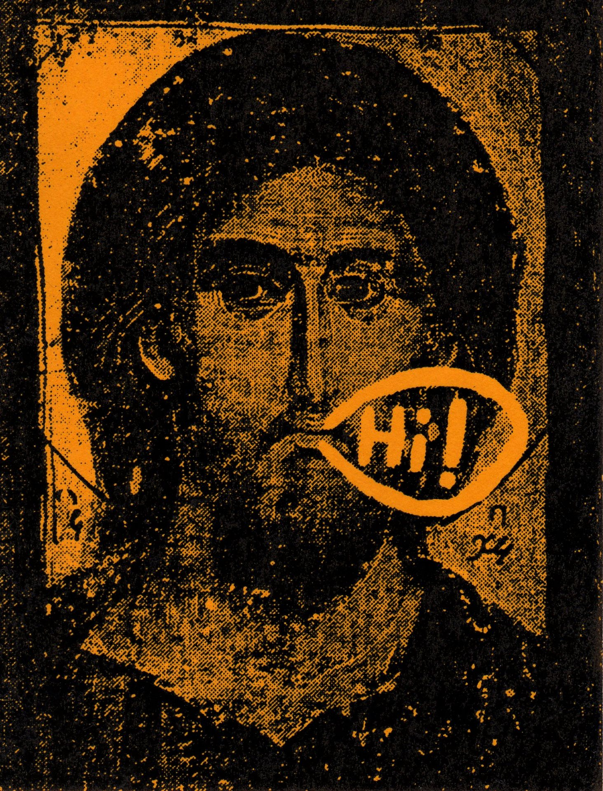
We were up and running. My best friend and co-manager of the store was good with merchandise, adept at knowing the value of things, and could carry heavy objects. I was good with managing people as well as taking care of money and paperwork. We had many volunteers from all walks of life willing to help us in the store. It was hard work, but there was such grace. Before long, the foundation had a monthly source of income and we were able to pay the bills to run the store. For me it was a peak experience of sorts, in that the store combined business, recycling, charity, human effort, and love, all touched by a humble grace and divine presence. Money from the store helped expand the foundation’s programs, including a summer camp for the kids.
I’ll never forget one eight-year-old boy at the foundation’s summer camp. All he wanted to do was be a normal kid and play baseball. He knew that he did not have long to live but faced his destiny with such courage, wisdom, and peace. The memory of the look of strength in his eyes has given me pause whenever I have faced difficulties in my own life. He was wiser and stronger than any adult I have ever met. He was able to play baseball that day at camp, just as he had dreamed of. He died a few weeks later. He was a hemophiliac child. HIV/AIDS ravaged the hemophiliac community in the early days of AIDS.
One donor was a peanut butter heiress who had started an orphanage and school in Indonesia. She had a couple of storage units filled with family belongings that she had been holding onto for years. She called me one day and said it was time to let them go. It took a team of five people an entire day to go through all her stuff. While we sorted through her belongings, she kept us well fed and entertained with stories of her family and travels. It was a great windfall to the store and the foundation.
The thrift store was in Seattle’s bohemian neighborhood of Capitol Hill. Sort of a gay/goth/grunge mixture of residents blended with an older, working-class community. Our store volunteers included an intuitive and loving woman whose husband was among the “disappeared” in Egypt. Her health was not good, and one Halloween, when she ended up in the hospital, we dressed up in costumes to visit her. Another woman was a sweet, firecracker-sharp, red-haired, chain-smoking New Yorker with a gay son. She could manage anything and always stunned me with how much she could accomplish and then ask for more to do. We also had an intern, a young man who was a rich kid living like a pauper in rebellion against his father—a parent who had no time for his kids. Yet the young man was patient, reliable, and kind to everyone. The music scene was just beginning to boom in Seattle and young people were arriving every day. For a few weeks, we had a young man helping out who had graduated from a prestigious East Coast college but was homeless, so he lived in the back of the store in exchange for working. A kind woman who I knew died and left us many of her possessions, including some valuable Eames chairs. Our homeless volunteer recognized the value of the chairs and wanted one, although he could not pay for it. We let him carry around one of the Eames chairs in his car for several weeks before he finally realized the absurdity of it, and he gave the chair back to us, so the proceeds would go to the kids.
After a year of running the thrift store, living on a minimal but adequate income, and working six days a week, I was nearing exhaustion. I began to question how I could continue. Our Lady came to me again and gave me the message “Seek Ye Refuge in the Garden, Restored.” I didn’t know what it meant at the time. There could be many meanings really—rest in the beauty of nature, or possibly—rest in the Heavenly Garden, restored to Grace. It was a profound message that touches me deeply to this day.
I arranged to finally take a break from running the store and retreated for a few days to Orcas Island, near Seattle, for rest, contemplation, and relaxation. I returned much more balanced and refreshed. I knew that I needed to take more time for meditation, but I wasn’t sure how to do that with all my responsibilities. Again, I just carried on and let life unfold.
A few weeks later, we received news from the landlord that he had found a tenant and we would have to move, unless we could pay full-market rent. The thrift store’s revenues were modest, and we could not afford to pay the full rent and support the foundation. We looked for another location, but nothing was suitable or affordable. I meditated and asked Our Lady “what should we do?” A few days later I felt her quiet presence come to me again. She said that it was done, our work was complete, and we should just let it go. I was sad but I knew it was true. She said our store had been given life for a brief time, similar to the brief but beautiful life that a child with AIDS experienced at that time. She also said that there was another message she wished to tell me, and she would visit me again.
In the final days before the store closed, we were still attempting to find another location to carry on the work. I knew inwardly it was unlikely, but I was still hoping. One evening, again just before bedtime, Our Lady filled the room and my being with her presence. I became still and filled with peace, tears welling in my eyes. Her message was “Lay Down Your Weapons.” I understood this to mean to just surrender and let the store close, and to not make any further efforts to continue. Once I understood this, she said there was more. I was shown a vision of what “Lay Down Your Weapons” meant for the world. Our Lady appeared all around the world, in various forms, speaking in many languages, touching the souls of children of all cultures, conveying the message that it was time to “Lay Down Your Weapons.” Children knew that it was time to end war, and they were drawn together through this miraculous appearance to make this happen. With the power and grace of Our Lady, I knew that it was possible. I asked her if the time was now and she said “not now” but that I would know when the time had come if I listened to my soul. I also understood that to lay down one’s weapons applied to more than just weapons of war and included all the things human beings use as weapons to harm one another. Laying down the weapons of war was the first stage of human beings learning to lay down the other weapons such as the hoarding of money, food, water, resources, etc. It was a step toward healing and uniting mankind to a next level of living.
I have often wondered when or if her final vision would occur. The message is simple really. How do you stop war? Lay down your weapons. It is common sense. We are all brothers and sisters living on this planet. War is family abuse on a massive scale. The family can be healed. There is hope.

CHAPTER 4
Dreams and Nightmares
2006–2007

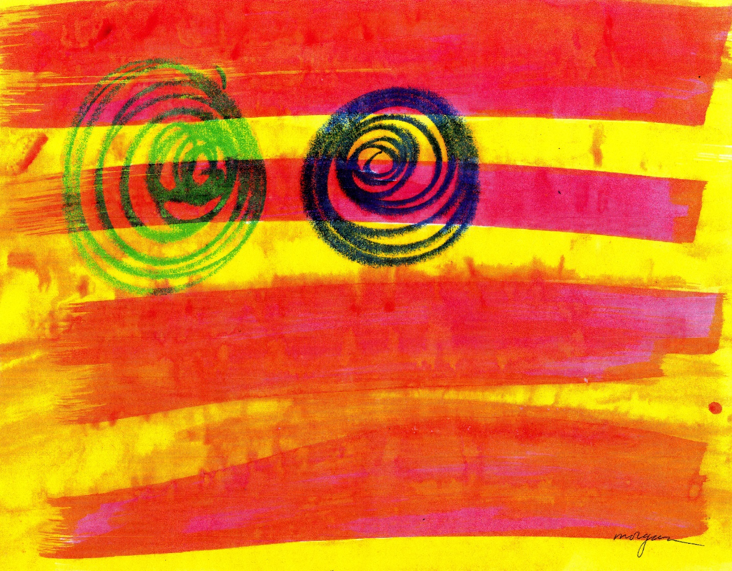

“Dazed” painting by Adam Sunshine
I was injured in the workplace in 2006. It was a high-stress job, with a difficult boss who was the CEO. Doctors and therapists have identified the kind of behavior she exhibited as that of a “malignant narcissist” personality type. She was insecure and abusive. Her psychopathic behavior required a repetitive pattern of targeting employees with abuse, often resulting in their quitting or getting fired. Scientists have discovered that psychopaths have an imbalance of serotonin and dopamine, causing them to act out in harmful ways to other people. In addition, I was sexually harassed by another manager, then viciously retaliated against by the CEO. The results were that I became permanently disabled with Post-Traumatic Stress, Panic Disorder, and Depression. While it has been good that women have begun speaking out against sexual harassment and retaliation, it is often overlooked that men can be targets as well. Tarana Burke, founder of the Me Too movement in 2006, originally wanted to empower women to speak out about their experiences. Now Burke has stated that it has grown to include men and women of all colors and ages. So I say, “Me Too.” I lost my ability to read and comprehend numbers for several months. Panic attacks disabled me from leaving the house or traveling by car, even as a passenger. Muscle tension led to neurological problems, fibromyalgia, degenerative spine issues, asthma, and respiratory distress.
My first warning sign of Post-Traumatic Stress Disorder (PTSD) occurred a few days after the sexual harassment incident. I later learned that my brain had been flooded by the stress hormone cortisol, which is released any time our “fight or flight” signals are triggered. But if we can’t fight or run away, the result is our brains sometimes just break, so to speak, an event that used to be called a “nervous breakdown.” I was getting panic attacks at work, at home, or even on a hiking trail where I usually felt at peace. I thought I would be fine once I was away from the toxic workplace, but that was not the case. When the symptoms lasted for more than three months, I was diagnosed with PTSD.
For years, nightmares played out in my body and my mind during both waking and sleeping hours. For the first few years, the most common nightmare was being at work at the job where I was injured. I was either given too much work to be done and/or I was completely ignored. Either way I felt trapped and alone, with no emotional support or connection. I was always full of anxiety and felt there was no escape, just a sense of being trapped. Later the environment changed, but I was unable to find my way home; there was always some obstacle that prevented me from getting home. I still sometimes have those nightmares today, and they are unpredictable, seemingly having no relationship to my ordinary day. In this particular dreamland, I felt like a ghost, wandering and unable to find my way home. But in the dream/visions I talk about in the next chapter, I found a stable peace deep inside while my mind and body were disabled, and I am so thankful for them.

CHAPTER 5
The River of Dreams
2006–2007
In August of 2006, while at Lake Tahoe for a few days at a friend’s house, I had what I call a dream before sleeping. I flew up above the clouds and beyond the earth so that I could look down upon the sphere of clouds, land, and ocean. I kept going past the quarter moon until I was deep in space with the stars whooshing past, until I just stopped in space among the stars. It was quiet—I wondered why I had stopped there but accepted that this was where I supposed to be. The dream/vision ended and I become aware of myself in the bed and the ambient sounds in the house.
A few minutes later, the dream/vision came back, and I was whooshing through space again with stars flying past. I descended quickly and saw a large, stone-like pyramid structure that had right angles of varying sizes at many sides of the pyramid. It was more like a Mayan pyramid than an Egyptian one. It was much taller than a classic earth pyramid and I could not see the bottom of the structure. As I neared the top it opened, and I flew deep down a dark hole. I wasn’t scared and simply accepted the journey. Deep inside, the shaft opened into a massive cavern with mysterious walls. I slowed and stopped at what appeared to be a wall with library-like shelves lined with what appeared to be books. One of the books moved out slowly, and I knew this book contained a soul. Each book was a soul of some living being. Some had lived before, and some were yet to live.
A shrouded being approached me to show me the book. It was kind of creepy, and I didn’t know if the being was friendly or hostile or neutral. When the being opened the book it showed me an image of my head on the book, indicating that I was to die like everyone else that was placed in the books of this “eternal” library. I thought, well that sounds normal, we all die and I am no different than any other living being. It did give my ego pause, though, and made me wonder if there was something I could do that might change this future destiny. It seemed so lifeless to be placed in this library. Another shrouded being approached me, but I feared it was not friendly, and it projected ugly “demon-like” features. The being left the vision, and I meditated on the question of what my choices were to be for my remaining time on Earth. Then I felt a subtle force of light and energy entering into my being through my head and into my body. It was quiet and light and filled me with a gentle peace that offset some of my uncertainty and fears. It felt as though just a bit of grace had entered into my being, not filling it entirely but just enough that I could contain.
Later on that same summer, I was at home in the Lake of the Pines, in Auburn, California, and I did a short meditation before bed to clear my feelings. Before sleeping I saw a vision of a gold band of energy surrounding the Earth, hovering, and vibrating slightly above the ground. This energy band represented the goodness and love of all the people and beings on the earth—past, present, and future. I felt myself being lifted into this energy. It was so good to be in this field, it felt like home. I felt that I would be drawn to people and places and beings that lived in this energy. Then I saw a column of people, heads and arms lifted up. The column kept going up and up beyond the earth, beyond the point that I could see. After that, I saw fragments of writing in a language I did not recognize (it looked like Hebrew or Sanskrit lettering). I kind of freaked out at this point because I thought it might be part of a sacred message, and I did not feel worthy to see such a thing.
Dreams and visions, 2006–2007
I.
I received a vision of Mary who appeared in her recognized image and then began morphing into a variety of feminine forms, beautiful and ugly, loving, and violent. It was a little scary and yet the feeling beneath the form was that all these images and expressions were She. Beneath the forms, the basis and truth were goodness and love, despite what I might see and experience in this world.
II.
Just before falling asleep, I received an image of a smiling old man. He exuded happiness. I knew he was there to comfort me and be a companion guide through what I was going through and about to experience. Without speaking, he identified himself as Elijah. He warmed my heart, but did not express any requests or guidance, just being.
III.
Sky opens up like a curtain and Jesus is riding a chariot pulled by galloping horses towards the Planet.
A tiny infant Jesus is in a glass cylinder, like a candle glass, outside a church sanctuary. The sanctuary is located in some desert mountains with red brown rocks and sparse pine trees.
October 2006
A light appears in a dark space, generated by a being. I felt the presence but no form of Jesus.
Jesus appears with long hair and clad in armor. He is smiling and waiting, emanating a feeling of confidence and patience.
April 2006
Jesus and I are walking down a rocky path. Jesus tells me that what we are both working on will take thousands and thousands of years.
IV.
Dream/vision before falling asleep: A large truck pulled up a gravel road and unloaded more than a hundred cows. As the cows, black-and-white Holsteins, left the truck ramp, they knew instinctively that they were “home” and proceeded up the drive to the farmhouse and ranch. This was their sanctuary, where they knew they could live their lives in peace, without threat of being eaten or killed. They communicated to me telepathically, as animals sometimes do, a tremendous sense of gratitude. In essence they said, “ah . . . it is so good to be home with you.”

CHAPTER 6
Pilgrimage to Bhutan
2007
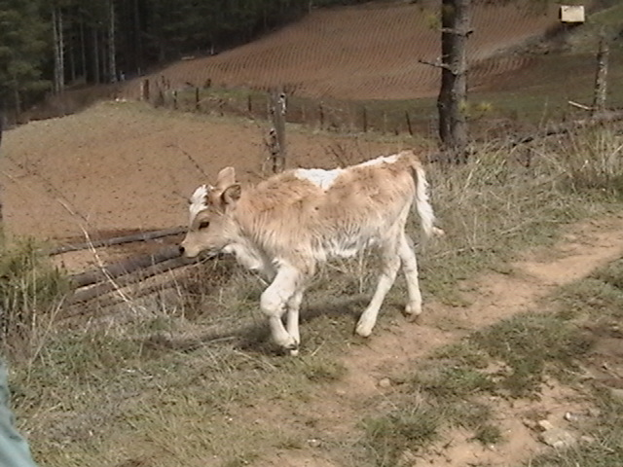
Calf on farm road in Bhutan

Bhutan, The Kingdom of Happiness, is a fascinating jewel of a country, tucked into the Himalayan Mountains between India and Tibet (China). Also known as Druk Yul, Land of the Thunder Dragon, it is one of the most isolated countries in the world. Tourism is restricted by the government, and it is often described as the last surviving refuge of traditional Himalayan Buddhist culture.
Once I had undergone lengthy mental health testing, I received a diagnosis, and, with the help of a good psychiatrist and individualized biofeedback therapy, I grasped the significance of being unable to work for at least five years. Without further trauma it was hoped that I would heal. I tried working part time as a tax accountant but found I could only do that at the risk of continuing panic attacks, as my brain unconsciously interpreted oncoming vehicles as threats to my survival. Hence panic attacks in vehicles became common and crippling. I had hoped to be able to work once I was out of the toxic workplace. But it turned out I needed a long time to heal. Yikes. I tried to make the best of it and decided to go to Bhutan, as, with my health slipping, this was probably my last chance to travel such a great distance.
As a child I had collected the beautiful stamps from Bhutan. I was fascinated by all the exotic, near paradisical kingdoms in the Himalayas. Now it was time to go and have an adventure, rather than mope at home. The last six months had been so difficult—finding an attorney, finding out the extent of the mental damage, and figuring out how to survive on Disability. I chose flight!
I read an article about the proclamation from the King of Bhutan stating that the purpose of government is to promote the happiness of people. In Bhutan, where the culture is 97% Buddhist, a higher priority is placed on the Gross National Happiness over the Gross National Product. They study and measure the happiness of their people, based on the premise that true development of human society takes place when material and spiritual development occur side by side to complement and reinforce each other. I was fortunate to get the last spot in a tour visiting Bhutan in March and April of 2007.
Our journey, sponsored by a small company in San Francisco, started in Bangkok. Our group of eight, including several St. Mary’s College alumni and a De La Salle Christian Brother, arrived at the only airport in the country, in Paro. We were just in time for the Paro Festival, a four-day event that celebrates Guru Rinpoche, the spiritual father of Bhutan.
At the festival, a series of sacred dances were performed in colorful costumes and fierce masks to the sounds of clashing symbols, long horns, and drums. The local people were dressed up in their finest traditional wear.
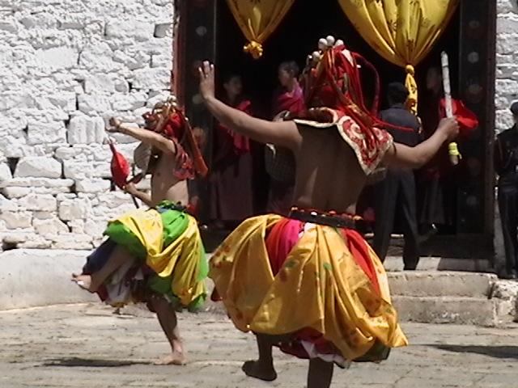
Dancers at the Paro festival, Bhutan
The next day we hiked up to Tiger’s Nest, a beautiful monastery built into the rocky mountain cliffs. Ponies carried some of the people up the steep trail. Along the way spring flowers were just beginning to bloom, including rhododendrons and forsythia. I was surprised at how many plants were similar to ones we had at home in Nevada County in Northern California.
Next on the schedule was a visit to Thimpu, the capital and largest city in Bhutan. A growing city of 100,000, Thimpu felt like a cross between an Asian and Swiss village in a natural setting, similar to Durango, Colorado. One thing I particularly loved was that there were no traffic signal lights in Bhutan. They had installed one in Thimpu but the residents complained that they missed the traffic policeman, so they gave him his job back and took down the traffic signal light. That also meant that there was very little traffic. They had roads and vehicles but just enough to serve the needs of a population slightly less than a million people in the entire country.
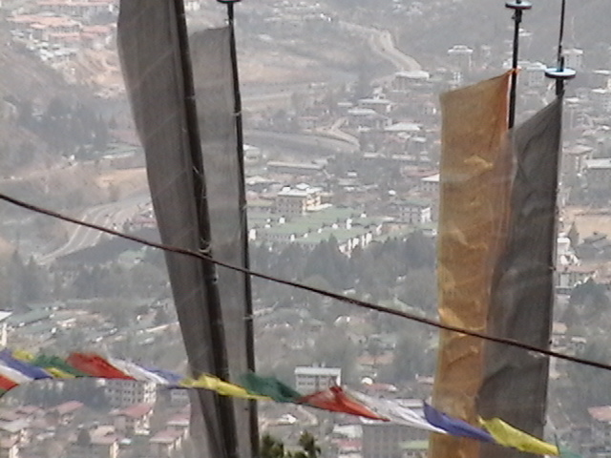
View of the city of Thimpu from a mountaintop, Bhutan
In Thimpu, we visited a paper factory where they made parchment out of daphne plant fiber; went to the National Post Office where the famous Bhutanese stamps are sold; and walked through the local farmers’ market, where we saw hot chiles, yak and cow cheese, red rice, bricks of tea, and heavy Tibetan turquoise. We toured the Museum of Textiles, and I was impressed with the quality of the unique textiles, especially the silk-on-silk fabrics. We also went to the School of Traditional Arts and Crafts to see sculpting, painting, wood carving, music, and slate stonework. It was great to see the efforts made to educate the children and to maintain the traditional cultural arts.
In the evening, we had tea with a Dasho, or knight, one of the highest-ranking people in the kingdom. He spoke about Buddhism as it related to the everyday life of the people. I learned that before it was called Buddhism (they did not want to worship the Buddha but to learn from him) it was called Nangpa, which means “inside.” This echoed my own religious training that the Kingdom of God lies within, so I felt that I bridged a gap in my own understanding of what had at first seemed so foreign. Some of the Catholics in our group understood that the statues were not “idols” but symbols of the inner life. They appreciated that the Buddhist enjoyment of ritual was just a variation of the rituals used by Catholics to enhance their devotion.
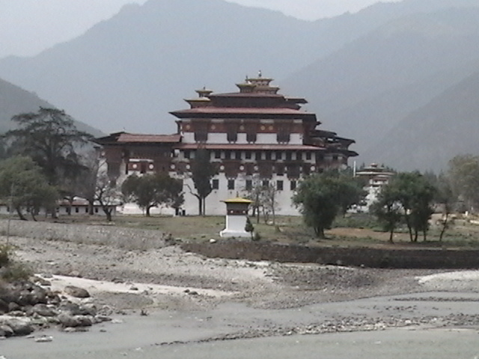
The Punakha Dzong, Bhutan
Our next stop was Punakha. The monk body of Bhutan is in residence here from October through April. Winters are mild and the climate is somewhat dry. The Dzong (fortress) is set on a dramatic spit of land at the confluence of the Mo and Chu (Mother and Father) rivers. Just before we entered the temple, our bus made a stop at the river. As I looked over at the Dzong my heart began to beat fast and a powerful feeling of déjà vu overcame me. I wasn’t sure if I was having a panic attack or what was going on. My tour group friends were alerted to my health condition and were very kind and supportive. They came over and made sure I was OK. It was so powerful I was trembling, yet I was all right, it was not a panic attack.
We received special permission to visit the interior of the main temple while the monks were chanting. Massive statues of Buddha, Guru Rinpoche, and the future Buddha, known as Maitreya, were inside, surrounded by huge sandalwood pillars decorated with gold-plated etched bands. The painted murals were intricate and fascinating, depicting all the stages of Buddha’s life. The chanting never stopped.
After that we walked around the fortress along gentle paths that the local people used to cross over the two rivers. At one bridge a group of student monks spoke with several of us in basic English. As I crossed over one of the long, narrow bridges it was not so easy to keep my balance in the wind. Along the side was a water pipe that was leaking, and a young boy in traditional costume stood over it, blocking it, so that I could pass without getting wet. It was very nice of him and was a gesture of kindness without a trace of begging for money. It was so refreshing to interact with people without always having to transact some kind of commercial activity. This was indeed a more balanced culture where they were not excessively prosperous but not poor—they had enough. To be content and happy without cynicism or needless violence was the practiced norm. Our hotel was simple but also fun, because a couple of soft, furry puppies were often playing in the yard.
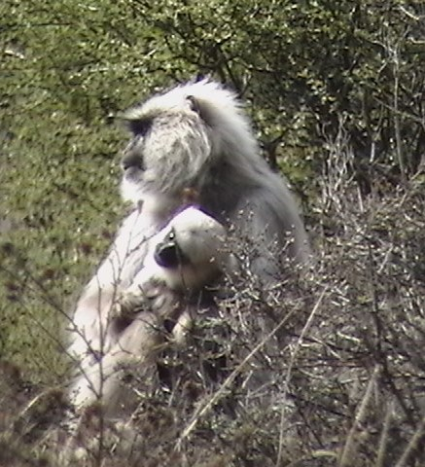
White monkeys in remote Bhutan

On our way to Bumthang, the religious heart of the country, we saw yak herders, white monkeys, golden langors (monkeys), and many birds. There are more than 600 types of birds in Bhutan. We stopped at a farmhouse where children came running up to greet us and cried when we had to leave. It was so pure and sweet to be loved by children who are instantly attracted to meet new friends. 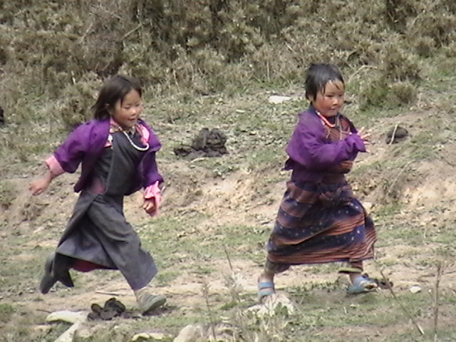
Children running from farmhouse to greet us, Bhutan

White magnolias were blooming at 9,000 feet, and pink azaleas were just beginning to blossom. In Bumthang we stayed at a new, deluxe hotel that made me feel like I was at Lake Tahoe. We toured two more famous temples and sampled the local buckwheat cakes and noodles.
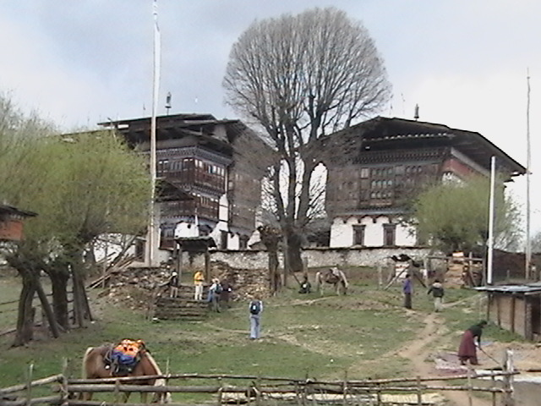
A seventeenth-century palace owned by Ashi Kunzang Choden in rural Bhutan
One day we visited the seventeenth-century palace owned by Ashi Kunzang Choden, a noblewoman and one of Bhutan’s most celebrated authors. The palace is also a museum with unique historical artifacts. A traditional way of life is still practiced by the local people. We witnessed this by watching women thresh early harvested wheat. Ms. Choden also had tea with us one evening and spoke to us about the unique cultural rights of women in Bhutan and the historical value of textiles. The next evening, while still in Bumthang, our group had tea with a district judge. He spoke about the judicial system and the upcoming changes in Bhutanese government. The King had decided to move to a democracy from a constitutional monarchy. We asked why the change, when things seemed to be going so well? The country is clean and peaceful, the people have free medical care (including flights to India for certain operations), and education, but the judge replied that the King said he would rather change to a democracy during a time of peace, unlike most countries that evolve to a democracy through war or other volatile changes.
Silk weaving from Bhutan
Our remaining stops included a visit to Trongsa, another religious Dzong first built in 1648, set on a hillside in a deep river gorge. Waterfalls spilled out across the gorge and into the river below. Clouds drifted up and down the hillside forests and terraces. We crossed the Pele La pass at close to 11,000 feet and stopped in Gangtey, home of one of the oldest (thirteenth-century) monasteries. A restoration project was underway. The rare, black-necked cranes stopped in this high valley, also known for potato cultivation.
As we neared the end of our journey, I reflected that Bhutan lived up to my expectations and exceeded them. Religious life permeated the culture. Our hotels ranged from rustic to first class and were always clean. The food was much better than I had expected. Our meals were usually served buffet style and always included red and white rice, chiles and cheese (the national dish) and a variety of eggs, tofu, beef, pork, and vegetables. The most exotic food we tasted was yak meat, yak cheese, fern fronds cooked in garlic and butter, and butter tea. We were careful to drink bottled water, and no one got sick on our trip. The people were always friendly and courteous and many of them were anxious to practice their English skills. Because there are four languages in the country, English is the standard language in school, modelled after the Indian education system. I was also impressed with the quality of the arts and handicrafts. The few stores contained high-quality paintings, textiles, jewelry, and religious artifacts. Many of these were museum quality, although one could still find reasonably priced gifts for friends and family.

Sixty percent of Bhutan’s land is held in National Parks. The pure air, diverse wildlife, and healthy human population show that it is possible for people to live in balance with our environment. It is not perfect but it certainly is pleasant—the rest of the world can learn a lot from Bhutan’s example.
I still have a dream of one day being some sort of cultural ambassador. Bhutan is sovereign, so it should be left to them as whether or not they would like any foreigners to visit or stay for longer than a few weeks. My dream, though, is to arrange art shows of silk textiles and paintings from Bhutan to tour to various cities and museums in North America and perhaps the world.
Photos from my journey can viewed online at:
http://www.flickr.com/photos/7879001@N03/

CHAPTER 7
The River of Dreams Continue
2007-2008
I. March & April 2007
I had a vision of Our Lady. She was alone, holding her head down, kind of slumped over, sad but not in total despair.
In a dream I was with a group of European artist/bohemian types. I felt awkward being around them until we started to do some inflatable trapeze dancing—it was really fun and graceful. Then a group of artists started chanting Om Mani Padme Hum—the sound was so incredible in tone and pitch. A transparent orb appeared in the room that began to move in response to the sound. It opened up an entire dimension of understanding that is not known from our earthly world.
Later in the dream I was in a new house in some kind of desert hills. A man took me to another house built by a mysterious English/Bhutanese person. It was a large house. Each time I looked it kept expanding into many wings, and many stories. A courtyard inside had a huge statue of a golden Buddha. When I saw the Buddha I cried and felt a great feeling of something good. Later I was walking up a path in a small village (that I had been to before in dreamland), up some stairs, past a modest little shop.
In 2009 I moved to Southern California. The house was a newer home and the view was like that in the dream I had in 2007. In 2007 I had no plans to move yet the dream foresaw my future.
May 2007
II.
Dream before sleeping — The face of Buddha appeared, a large gray, stone face with eyes closed and a gentle, kind smile. It lingered awhile and then the torso appeared and kept growing in length and girth. There were many details and intricacies to the body. At the lower part of the belly a door appeared. The door was closed and then opened from the bottom up. Inside, there was a wood floor in tones of red and brown, which moved about gracefully, sliding in multiple directions. The feeling was calm, safe, and alive.
III.
Dream before sleeping — A blue and gold being walked slowly and deliberately, almost mechanically, toward a central area. The being was human-like, with deep blue skin and gold-encrusted top layers on the head and many parts of the body. In the central area was a smallish gold being, Buddha-like, who was smiling and alive. The gold Buddha sat cross-legged and at times rose off the floor a few feet. The gold Buddha then changed form into a spinning gold ribbon of energy, somewhat like a double infinity symbol.
**
IV.
Dream before sleeping—A large, intricate, and magnificently, highly-detailed structure appeared. I viewed from above and closed in to see the detail, more complex than anything I have seen on Earth, many colors, and highly evolved details, sort of a combination of Asian and Baroque styles. There were no visible beings but the place felt alive as if it were a living being itself.
V.
Complex imagery of a young baby, an old man, and several stages in between that was too fast to grasp with my mind. Buddhist/Asian themes with some sort of understanding of light and a method of pure creation that has to do with being in a certain state that allows one to see and create from pure intent and emotion. Hard to describe but it is a state of perception from an inner place. Felt as though my mind and soul were being worked on, stretching, and growing.
VI.
Dream in the early morning — I was gliding through the air both fast and slow, close to the ground and slightly above it. But when I was in my body I was kind of stuck in a slow, somewhat painful mode. Later I popped into space, looked around at all the stars, then looked down and got scared because there was no ground, but I was OK and when I relaxed in space I was fine, feeling weightless and clear in my mind, free of pain.
***
In the summer of 2008, a series of wildfires in Northern California, where I lived at the time, made life even worse. For a month, the smoke was so thick many of us could not leave our homes for other than brief periods. My body began to fail and I landed in the emergency room again and again. I had been fortunate to have good medical care, but this time the physicians were stumped. Although modern science had saved my life again, I was sent home with little hope because they just could not find out the cause of my progressive collapse.
At home one night, deep in pain and anguish, I struggled to find the peace of sleep. Inwardly, I did not think I was going to die but my body was telling me otherwise. I just accepted where I was at and surrendered. Slowly the pain decreased and I felt my spirit lifted into what I can only describe as a dazzle of kindness, reflecting images of kindness received and given, so fast that it melted my pain and anguish. Beyond this I felt a powerful, magnetic force that was drawing me into Itself.
Then I became aware of my heartbeat, with the memory of the huge force that is our destination after leaving this world. A fragment of this place came into me and into my consciousness. I instinctively felt as though this would be enough for me to continue to live on here in this world. It was not time to die.
During this time I spent a lot of time with Toby Dog. He once saved me from walking right into a timber rattlesnake. He was off leash and going to a swimming hole we had been to hundreds of times. He ran back to me on the trail blocking me from going any farther. When I looked ahead I saw a snake as big as a python crossing the trail, slowly going uphill. We gave it space to climb up the hill but I stepped a little closer to get a look at its rattles and beautifully camouflaged snakeskin. Once it turned its head to make sure we were not a threat. I remember looking that snake in the eye and holding onto Toby Dog with one hand. That is the only rattlesnake I saw in nearly 10 years of living there and hiking hundreds of miles, usually with Toby Dog.
Toby and I were safe, and soon we were at our destination. This spot, about 2 miles north of Highway 49 on the South Yuba River, is perhaps one of the most beautiful rock canyons that I have ever seen. As a pup, Toby Dog once unintentionally swam over the side of a small waterfall, but it contained a mighty force of gravity from the fast moving water. It held one down longer than you imagine before popping your head out of the water. So, of course I was
South Yuba River spring runoff waterfall
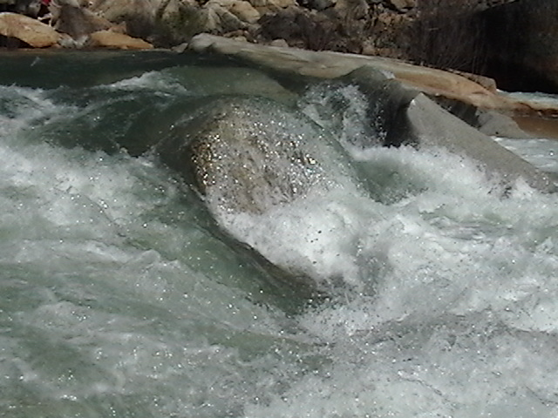
anxious, as he was still a young pup, not even a year old, yet he was adventurous. Whenever he saw me do something, he wanted to try it too.
Watching a dog swim is fascinating. Toby Dog had webbed feet from his Labrador side so he looked amazing when I would watch from underwater as he swam in some of the deeper pools. The water was so clean, with natural, sandy beaches appearing amongst the boulders. 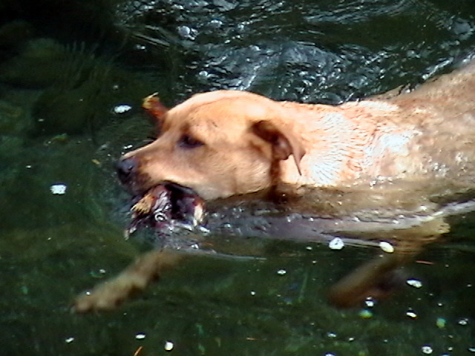
Toby Dog swimming at Edward’s Crossing on the South Yuba River
On one walk we went on during the hot summer of 2008 we swam with a family of river otters who appeared just upstream from us. Toby saw them and knew they were far enough away so as to not be a threat and vice versa. The otters kept an eye on us while having fun playing in the nice, cool, river water. It was so clean because there were no roads that crossed it upstream until you reached the high mountains. The water of the North Fork of the American River flowed through steep forest canyons for more than 50 miles. I love that California has so much open space. Despite the large amount of open land, a ranger we once ran into on the trail told me that almost 50% of the wildlife had disappeared over the last few decades.

CHAPTER 8
Transition South
2009
I moved from the Sierra Nevada Foothills in Northern California to Southern California in 2009 due to health problems related to climate change. Because of overdevelopment in the Central Valley, ozone pollution has risen dramatically in the past few decades, especially at certain elevations in the Sierra Nevada foothills, causing many people like myself to develop respiratory problems, often forcing them to relocate. It was a difficult choice to leave the foothills, as I thought I had finally found a home where I could live in a small town surrounded by incredible natural beauty. But it was no longer safe for me. Once I moved south, though, my respiratory issues improved, and I was able to stop taking two medications for asthma.
Not long after I moved to Southern California, I experienced an intense and unexpected occurrence during my first visit to the Swiss Hotel. Tears overcame me with a great fullness of emotion, accompanied by a strong presence of Paramahansa Yogananda. The owners were concerned by my unusual state. Then they told me that they were followers of Paramahansa Yogananda. This struck me, because years earlier, I had dreamt that Yogananda invited me to have a cup of tea and a chat in a small, humble trailer. I don’t remember what we talked about, only that he was welcoming and friendly, as though we had known each other for a long time.
At the Swiss Hotel, I sat down, and I felt an expansion and transmission of radiant energy through inner space coming out of my head and belly. It was unlike anything I had ever felt before. I felt the living presence of a powerful energy, in my intestines, literally moving up the walls and tissues of my inner organs. I also felt a comforting goodness, and I was not overwhelmed because Yogananda was with me and would be there to stabilize me. At first I thought, “oh no, another overwhelming inner experience that will take me down a rabbit hole to who knows where.” But then I was reassured—it was all right, I was OK, just alive in an energetic way that was different but not overpowering to my human body.
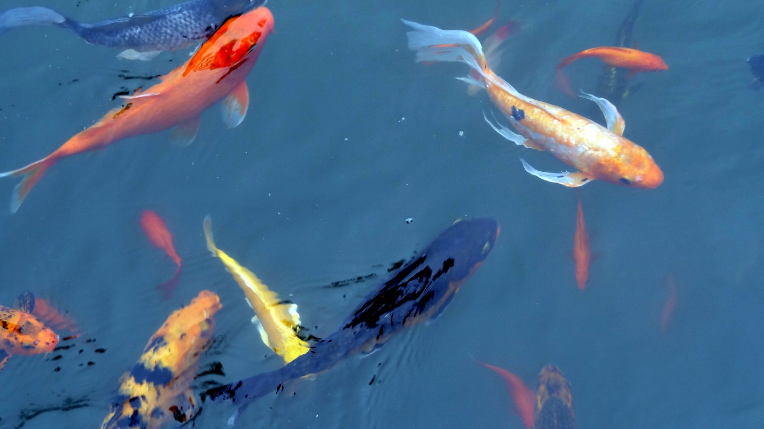
Koi fish at the Swiss Hotel pond
CHAPTER 9
The Dream Puzzle Becomes Whole
2011–2020

Chronic pain from so many issues prevented me from returning to the workplace, but I was slowly able to put together an art gallery on the web. Although it has hardly been a financial success, it has been seen by thousands of people, which was my primary goal. I met other artists there who I admired and who were kind.
The dreams continued for years until finally I found some inner peace and a reduction in mental anguish. I was also beginning to notice the connection between physical suffering and spiritual growth, which I didn’t fully understand but which I sensed was important. Maybe this becomes clear after we leave this world behind. Recently, I read some writing by a Japanese friend, who commented about extreme suffering as a path to the sublime, and that description resonated with my experience.
In 2016 I experienced an eye injury. I was in surgery the next morning, but the anesthesia made me sick because the doctors had not bothered to notice that the sedative for the operation conflicted with another medication I was taking. Yikes. Even worse, I was the one in a thousand whose surgery did not heal properly, so I underwent another surgery six months later. Nothing improved until I finally found a better doctor in whose care I finally could trust. Despite my physical challenges, I have met so many people who have experienced far worse conditions and suffering. So I count my blessings rather than my bad fortune. No one escapes suffering in this world, and I have had the help of so many good friends, doctors, and an extended family who cares for me and whom I love.
Like a river, dreams and visions come and go in cycles like floods and droughts. At times they are a constant, while at other times they go unremembered. Over the years, the nightmares of finding myself lost or without purpose gradually became less frequent as therapy and time ultimately gave me strength to dissolve the pains of the past and feel safe in the present. Of course human traumas continue, as we are often a broken people struggling to cope with a world out of balance. Dreams became my safe place, until gradually the natural world merged with my dream world. The following are excerpts from my dream journal over a seven-year period.
Dreams 2013–2020
5/25/13 Dreamt I was in an interesting, safe environment of artists in a public place with many mini environments in which I always felt welcome. Across the street was a large building. I was told it had a good history of cooperative and humane, philanthropic activity.
5/26/13 Dreamt of being by a small river with friendly acquaintances (none who I know in “real” life). We went for a walk but I could not find my way back. I just kept going into unfamiliar places, with higher and bigger mountains. Then I saw what seemed like an old military base that was being used for some other purpose that I did not know. People were friendly but not helpful in any way. This is a familiar theme where I keep wandering, like a ghost, without purpose, other than trying to find my way back to where I started in the dream or back home not knowing where that was. At least I did not experience trauma or a trapped/frozen feeling.
Later in the dream I saw my friend Mandy in downtown Seattle. We walked around in shops and on the street, later sitting outdoors where a video/performance entertainment event was occurring. We separated and I was walking towards home not sure if I was going to take a bus or walk all the way — some confusion here like not knowing where to get the bus or even how to get home.
7/18/13 Dreamt of a deep blue light that surrounded parts of my body and bone structure. It appeared sort of in between dreams and went off and on in an unpredictable rhythm. I could feel a slight electrical charge but it did not hurt. Beautiful color, that deep blue.
7/22/13 Dreamt, again, of a workplace where I struggled to find purpose. At least this time my “boss” was a man who was not abusive or loading me up with meaningless tasks that I could not achieve. He simply let me be and signaled that I was fine even if I was just puttering around or shuffling papers. Later the group from the office went to a restaurant. The waitress talked to the group but was not speaking in my direction so I could not hear properly. I asked her to repeat, but she just ignored me. It was a feeling that I am not worthy of communicating with, like I was invisible.
10/1/14 Dreamt I was at a Lucille Ball benefit for sick people, but I was in bed at the back as one of the sick people. She came up to me and gave me a present of a string puppet with large metal body parts.
10/23/14 Dreamt I was with Jere F. at a café that morphed into a secret Buddhist book and sacred text shop. I picked up three large books but put two back, as they were too heavy to carry. I was left with one large white paperback that was regular width but three times longer than normal. A woman dressed in white came up to me and pointed two fingers at my shoulders, just above my armpit, and said I had a deep cough in this area.

A dream from 2018
Dreamt I was walking in the air, but more like being walked by a force that moved things, including a gray-haired man, like perhaps an ancestor, who was in the air at a desk and greeted me with a big smile. I felt slightly cautious, like I was being called to the principal’s office or had to account to God for my mistakes. I did not recognize the man, but he seemed to know me. He reached out to greet me with a handshake.
Just then the alarm went off. I could still feel the dream space in which I was gently overpowered with a sense of no judgments, where all is forgiven. Or more like what happened in my Earthly life was of no significance and not worth thinking or worrying about at all. He telepathed to me that my new assignment was . . . I don’t know because of those Earthly alarms; you never can go back to sleep and dream the same dream again.
Love was the pervasive force in that dream space. Material things like bodies and walls existed in partially built dwelling cages that were in the air. Gravity was not Earthly but safe as a gentle force supported the flow of movements. Emanating from people and objects was a light that merged with the form, or perhaps fashioned the form in a dance of some magnificence. This light burst out of a man’s head and was so powerful that it lifted his head above the eyes to let the light shine out. The same light came from the walls, ceiling, and other forms in the rooms in the sky.
***
By 2019 I was feeling well enough to volunteer in support of one of the presidential candidates who did not ultimately get elected. But I enjoyed his words and others of like mind did as well. So I offered to take a shift at the booth sponsored by the candidate at the Palm Springs Pride Parade, which has become a blend of LGBTQ activists and families of all sorts. Sort of a Disneyland parade of tolerance, talent, and love. The people were so nice, kind, and polite. Unfortunately, I was left unattended after my shift and became a perfect catch for a sexual predator who restrained me. He put his hand underneath my shirt and groped me as though we were intimate partners. But we weren’t partners, and it was not consensual. I went to the police, and they told me I had a good case for kidnapping (the police said if a victim is moved even an inch it is legally considered kidnapping) and battery, but it would likely cause me further trauma to pursue it, as the usual outcome was community service for this type of man. However, they recommended that I contact the candidate’s office and inform the staff so that this would not happen to other disabled volunteers. Well, I tried more than a dozen times to contact them: I called, tweeted, wrote, and e-mailed the candidate’s offices. I was ignored, and again was made to feel invisible by a more powerful person, whose candidacy ultimately failed. Fortunately, I had the inner resources to rebound in a few months, but I don’t think I’ll volunteer for any more political booths. I let the time elapse for filing a charge with the police. The guy who assaulted me was just another drunk, gay man who did not respect boundaries, and once again I experienced what women have been righteously complaining about for years. Me Too! Men are just as afraid to report it, as somehow we are supposed to be strong enough to endure being abused. Nonsense, we are the same, full of fear and shame. No one should be abused, ever. We just need a cultural healing to stop it all.
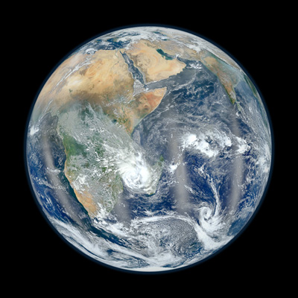
Earth the Blue Marble—photo by satellite

2020 Vision of Immense Beings
Four immense beings hover over the Americas, Europe, Africa, and Asia. The forces of play, truth, forgiveness, and transformation move through them. Their connection to Source is much stronger than that of most human beings.
Vision of Rising into Love June 2020
I was lifted by an unknown force. As I rose higher and higher my body began to grow younger, until I lost my ability to judge, think normally, or speak. When I stopped rising, I became a gurgling, innocent baby held in the loving arms of an immense “Father” who had long, straight gray hair and a huge smile. All around the space there was a powerful loving force. In fact, the Father conveyed to me somehow that the force had been dialed down to accommodate me, as the full force might damage my form as it is now. It was very humbling and comforting to have a real home, in that loving force, accommodative to all that is and is not.
CHAPTER 10
Animal Spirits Bring Healing
2001–2020
As the PTSD nightmares became less frequent, I found that spending time in the natural world brought me peace. The close relationships I had with my two dogs, Toby Dog and Lance, deepened my respect for their innate intelligence and authenticity. While I taught them, they were teaching me to accept myself, wounds and all.
Before I adopted Toby Dog, I had an experience with a bear. On one of my frequent escapes from the far too congested Bay Area I stopped in Redding, the largest city in the Northern California region known as the Sacramento Valley. I went on a hike in the Trinity Alps, where I met a Native American man. He invited me to go on one of his favorite hiking adventures.
During our hike in the foothills there was a lot of shade from the deep forest that covered the hills. It was just perfect for a hot summer day. We had not gone very far when he said he was thinking about doing a Native American Bear Call. Before I had time to comment, he was deeply involved in what sounded like a shriek, a cry, and a song all mashed up into this Bear Call. I saw no good reason to summon up a bear, but he was bound and determined to show me something.
Indeed he did. Perhaps an hour later, after climbing hills in 105-degree weather and sweating so much that we returned by way of the creek. My friend waited up the hill while I went down to have a look at the creek. It was maybe an inch deep and a foot or two across. I dipped my hands in the cool water and splashed some on my face. Fortunately, we were still in the deep shade of the forest when my friend whispered loudly, “Stay still!” I looked up at him. He was pointing across the hill to where a big brown bear was walking across the ridge. I thought “uh-oh, my friend is way up the hill and I am trapped between the bear and my friend.” Then the bear decided to come down the hill, not directly at me, fortunately, but straight down, about 10 yards away. Then he started walking towards me, but not directly, just ambling up the other side of the creek. My heart started pounding, I was frozen like in a dream, not really knowing what to do other than to do what my friend advised. That bear was old and big, and had an expression of concern, like—Who the heck was calling me while I was peacefully napping? What is going on? As he walked near me, he was only a few feet away but kept looking up the hill, not at me. He glanced over quickly, and our eyes met, but he could tell I was no threat. One swing of his sharp paw would have done me in—we both knew that. Once he was safely past, I breathed a sigh of relief. Then I heard a dog barking off in the distance. The bear got up on its hind legs, waving his paws over his head and roaring at the dog in the distance. The dog ran towards him and the bear roared again. This time the dog ran off going “yipe, yipe, yipe.” I walked slowly up the steep hill to rejoin my friend. In a bit of a daze he said, “See, that was the bear I called!” So it was, I thought to myself, as my heartbeat slowly returned to normal.
When I got back to the car a short time later, I saw giant bear claw prints in the dust on the car. The bear’s paws were on the back, the sides, the top, and the front of the vehicle. Yet he had done no damage and walked away. I was never sure if this bear was the same one we had just encountered. It may have been, and it was on its daily course of hunting and gathering, like so many billions of creatures had done that very same day.
The dreams that follow helped me both to heal from the loss of my two dogs and to allow me to become open to the animal world. I became open to animals not just in spirit, but in Earthly reality. By learning to respect wild animals and share the Earth with them, I have been able to experience safe encounters with bears, snakes, wolves, otters, coyotes, deer, foxes, elk, and many species of birds. Recently I went outside one evening only to be surprised to see a burrowing owl, an endangered species, just standing in the walkway as though it was waiting for me. It has returned again and again. It is good to know that it feels safe here in my informal sanctuary.
Scientists don’t even know how many species exist on our planet, with estimates ranging from five million to a trillion, due to the biodiversity of all life forms that we have barely begun to understand. Since the sixteenth century, humans have caused the extinction of nearly seven hundred vertebrate species, yet our current unsustainable path projects the extinction of more than one million animal and plant species within just a few decades. The war with Nature must be stopped.
Dreams
5/27/13 Dreamt about Toby Dog! He popped out of a building and jumped up, putting his front paws on my shoulders. It felt so good to see and touch him, feeling his love and happiness. Best dream in many months. All too brief, but still it gave me a good feeling that lasted throughout the day.
11/18/13 Dream of Toby Dog looking me directly in the eyes. I love that! Eye to eye, soul to soul. Also I dreamt of Yosemite and being with a group of good people, one of whom suggested I go to a beautiful place he pointed to on a map. I gauged the distance of the walk to be just what I was capable of doing physically.
11/20/13 Toby Dog was driving a white hatchback car in reverse, to find me. He was nearby, waiting patiently in the back of the car until I walked up a hill and found him there. It was so nice to see him. A lady in a car also followed Toby, concerned about his safety, and she waited there patiently until I showed up and could make sure Toby dog was safe.
2/20/14 Dreamt I was being driven around by Dad along with Toby Dog, who did not look at me but was more attuned to Dad. We stopped at a house along a small river that seemed to be for sale. It was a large home with extensive damage due to flooding of some sort. It was nice to see Toby even though he did not interact with me. Maybe he is with Dad in the other realm and they are taking care of each other in some way. At times, the house we looked at was by itself, and at other times there were other homes in the shady canyon.
5/22/14 Dreamt I was at the door to heaven. It was a plain white door and I was holding on to the handle, feeling a sense of weariness and relief, thinking, and saying to myself “Finally.” I did not open the door but rather looked back and called to my dog, Lance, waiting for him to join me before we both went in. This looked like the same door I had seen in another dream, when Jesus held the door open for Toby Dog, who ran through it with his usual smile and happy tail wagging. That dream was a day or two after Toby died, in September 2012.
9/11/14 Dreamt of Toby Dog or rather he just appeared in my inner vision. He seemed large, almost four feet tall with big eyes looking directly at me. He seemed extremely healthy and happy.
12/25/14 I dreamt I was playing with lions, like in the movie Born Free. One female lion started playing a bit rough and then Toby Dog appeared, same color as the lions and he turned the rough play into gentle play, thus protecting me and diffusing the situation.
Toby Dog with a stick he fetched in Lake Tahoe
***
During one walk up the river itself I saw a vein of gold. At first I did not know what I was looking at, as I could not tell if it was a reflection. Yet when I grew close I could see a large vein of gold, several inches thick in places, and just a fraction of an inch at others. But it stretched more than 10 feet, so it was quite a lot of gold. I was glad that when Toby Dog and I came back down the river it was covered over by sand, so that no other human eyes would know this gold was underneath. It may never see the sun again. Or maybe it will dance with us as it has done for many centuries.
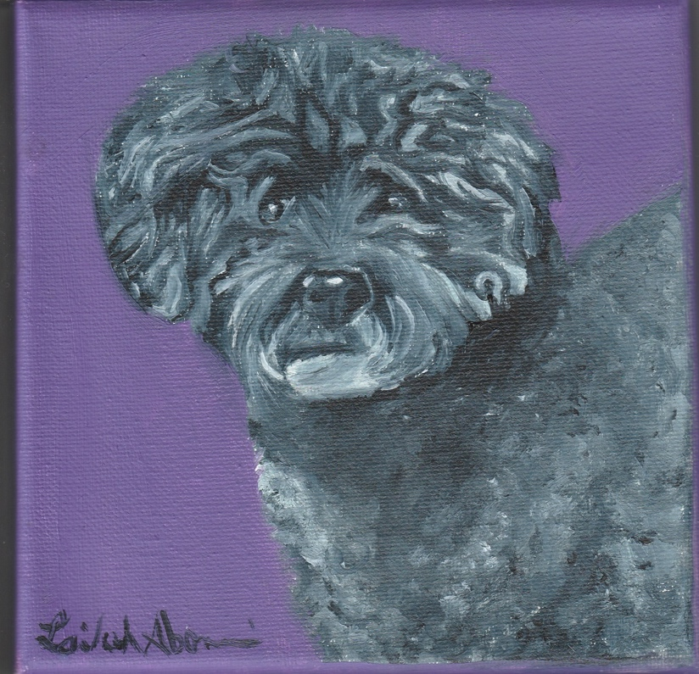
Painting of Lance, a gift received in 2020
Lance, my service dog, died at the end of 2019. Even though by then he had become blind, he was playful and loyal, still trying to be my working dog, even though he was limited in his abilities. The final year was full of both grace and exhaustion. We often just lay in bed, simply being with one another in our painful bodies. I have never before been with a dog twenty-four hours a day, seven days a week. It seemed entirely normal. We were good companions for each other.
In April 2020, I finally had a dream about Lance. He was walking with a friend and myself. It was clear that he could see again, as he often looked up at me. A few nights later, he appeared in a dream by himself. He began trotting toward me and jumped up onto my chest. Instead of remaining in the form of a dog he disappeared into my chest, wrapping himself around my heart. I could feel his presence, and I told him he could stay there as long as he wished. It brought comfort to both of us. Dreams can provide healing to our grieving brains. This certainly worked for me. I had the strength and invisible companionship to move forward with my life, knowing he was with me in a way that I had never imagined.

At home in late November 2020, I was sitting quietly, watching our new President-Elect announcing some of his Cabinet members. Suddenly, I felt a subtle being near me. It was the spirit of Toby Dog, who has only appeared in dreams, and rarely at that, since his death eight years ago. I felt his spirit slowly approaching me, and much like Lance, but slower, I could feel him enter into my belly, arranging himself so that he was in a fetal position touching Lance, who was still curled up around my heart. That same night I had a dream where Toby Dog was his former self, active, joyful, and alert. He went with me to what appeared to be some kind of social event, with hundreds of people wandering around a large house with extensive gardens. Sometimes the people were alone, others were gathered in small groups. They seemed to be both normal and concerned about something. I recall asking a woman with cropped hair and black glasses what was going on? She said they were gathering because of the uncertainty in the world. She continued to say that while many things seemed to be functioning normally, there were more signs that we were facing the brink of some kind of collapse that no one knew how to face. Just then I looked down at Toby only to find that he had disappeared. Unconcerned at first, I looked around the room but could not see him. I got up from my chair and went outside. Off in the distance, in a meadow of grass, I could see his golden body lying still on his side. Although he could have been asleep, I knew instinctively that he was dead, as somehow my conscious mind became self-aware within the dream.

Now the spirits of my two dogs are within me. It makes me feel complete somehow. Although one doctor keeps telling me I need another dog, I feel that twenty years of caring for dogs is enough. I am so grateful that I had so much time to spend and learn from them. There comes a time to let them go, kind of like with raising children. Instead of this world, though, Toby and Lance have moved into a world I don’t know yet, or perhaps have only touched through dreams and visions.
In the Spring of 2020, just before the COVID-19 shutdown, I began to hear the birds outside my home in a new way. We often take them for granted, living amongst us in their own worlds in tiny homes they’ve built, and hunting and gathering in the wild instead of supermarkets. I found their joy uplifting to my spirit. Then two events brought me even closer to their unfamiliar world. One day, I heard a bird hopping in the backyard. Then, splash, it had hopped right into the swimming pool! Unable to swim, it quickly became waterlogged and just floated there, not knowing what to do, with its tiny head peering up at me. Simple solution. I grabbed the long pool-cleaning tool, and it was just the right size to scoop the bird gently out of the water. Once out of the water, the bird stood by the side of the pool, unafraid of me, and let itself dry off in the warm sun, while gravity allowed excess water to drip away. Feeling safe now, it just walked off into the bushes, chest proudly full of fresh, dry air.
A day or two later, I was in the front yard when something fell out of the tree right next to my feet. It was another hatchling, learning to fly. It just fell straight to the ground while trying to flap its wings. It walked a few feet away and pretended it was invisible in the wild grass. It was so still it did not even move its eyes, maybe hoping that it would be invisible to a predator. After seeing its beauty close up, I stepped back slowly so as to not frighten it. Then the bird sauntered slowly away, around the corner of the house.
Since then I have seen the two birds frequently and nicknamed them “The Twins.” When one or both saw me outside they did not fly away. Instead they gave me a friendly “chirp!” and this launched a duet or trio of me chirping and then one or both of them chirping, sometimes lasting so long my mouth dried out and I had to stop. I had no idea that wild birds could feel safe enough to communicate with our species. As the hot summer grew hotter, I began to put out water for them. Instinctively I did not feed them, so that they would learn to hunt and gather food that was right for them. Soon the word was out about the magic watering hole, and doves, quail, hummingbirds, mockingbirds, sparrows, and finches made appearances to get a needed drink of fresh water. It was such a delight to watch them from the window as they looked around to make sure they were safe to indulge in long drinks, enough to last them through the hot day. I was surprised to notice that many of them followed a pattern of drinking three times a day: morning, noon, and just before dark, just like human meal patterns. Their needs were simple, and best of all they had no concerns or anxieties about our human worries. They were free to come and go as they pleased. It gave me much needed contact with the natural world while not having to worry about my declining physical state or pain hindering my ability to provide water for them. It was a simple task that I looked forward to each day.
As I write this in the winter of 2020, there are different breeds of birds sharing the water with the quail and the doves. Who knows, maybe I will get another dog, and the animal spirits will adapt along with me.

Author’s Note
The Rachel Carson Society of the Sierra Club, of which I am a member, allows individuals to donate a portion of their estate to the Sierra Club or the Sierra Club Foundation. Its honorable work in the areas of climate repair and conservation of both wildlife and wilderness will help assure the possibility that all species may co-exist on our small, miraculously diverse, planet Earth. After my passing, the rights to this book will go directly to the Sierra Club so that they may continue to preserve the beauty of our planet.

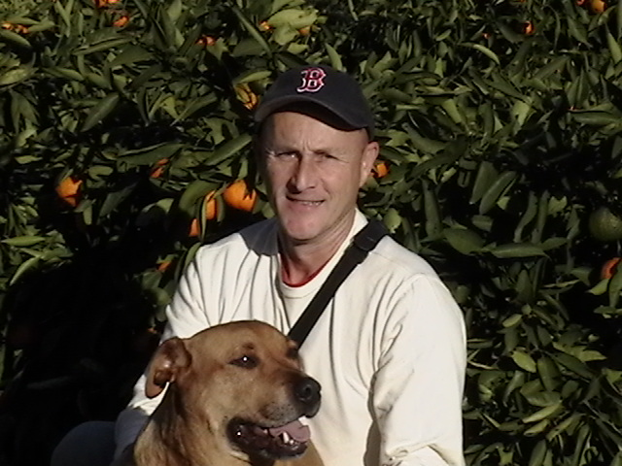
The Author with Toby Dog
Author’s gallery:
https://fineartamerica.com/profiles/adamsunshinegallery
Contact: riverofdreams@gmail.com

